MINUTES OF MEETING HELD NOVEMBER 28, 2011

The Common Council of the City of Somerset, Kentucky met in a regular session on Monday, November 28, 2011 at 7:00 p.m. with the following present: Mayor Eddie Girdler. Council Members: Jerry Burnett, Tom Eastham, Jim Rutherford, Linda Stringer, Jerry Wheeldon, Mark Beasley, Jerry Girdler, Mike New, Donna Hunley, John Minton, Jim Mitchell, and Pat Bourne. City Attorney Carrie Wiese and City Clerk David Godsey.

Mr. Beasley moved to approve the minutes of the regular meeting held on November 14, 2011 along with the reports as mailed. Mr. New seconded the motion. Upon roll call the following Council Members voted “Aye”: Mr. Burnett, Mr. Eastham, Mr. Rutherford, Mrs. Stringer, Mr. Wheeldon, Mr. Beasley, Mr. Girdler, Mr. New, Mrs. Hunley, Mr. Minton, Jim Mitchell, and Pat Bourne.

Mr. Wheeldon moved to approve the following Resolution authorizing a Grant Agreement/KY Homeland Security. Mr. Eastham seconded the motion. Upon roll call the following Council Members voted “Aye”: Mr. Burnett, Mr. Eastham, Mr. Rutherford, Mrs. Stringer, Mr. Wheeldon, Mr. Beasley, Mr. Girdler, Mr. New, Mrs. Hunley, Mr. Minton, Jim Mitchell, and Pat Bourne.

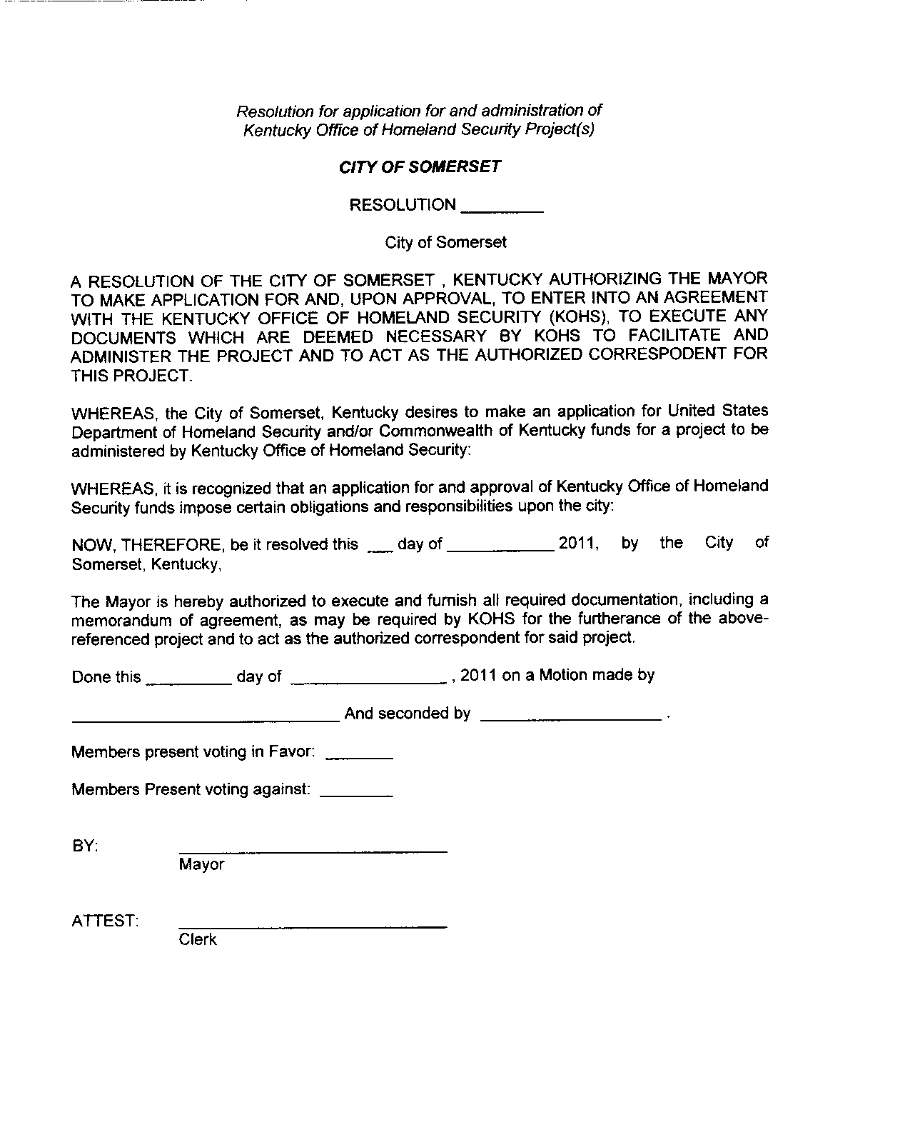

Mr. New moved to approve the following Resolution conveying of property from the Somerset Cemetery. Mr. Burnett seconded the motion. Upon roll call the following Council Members voted “Aye”: Mr. Burnett, Mr. Eastham, Mr. Rutherford, Mrs. Stringer, Mr. Wheeldon, Mr. Beasley, Mr. Girdler, Mr. New, Mrs. Hunley, Mr. Minton, Jim Mitchell, and Pat Bourne.

Page 1 of 3
Minutes of November 28, 2011

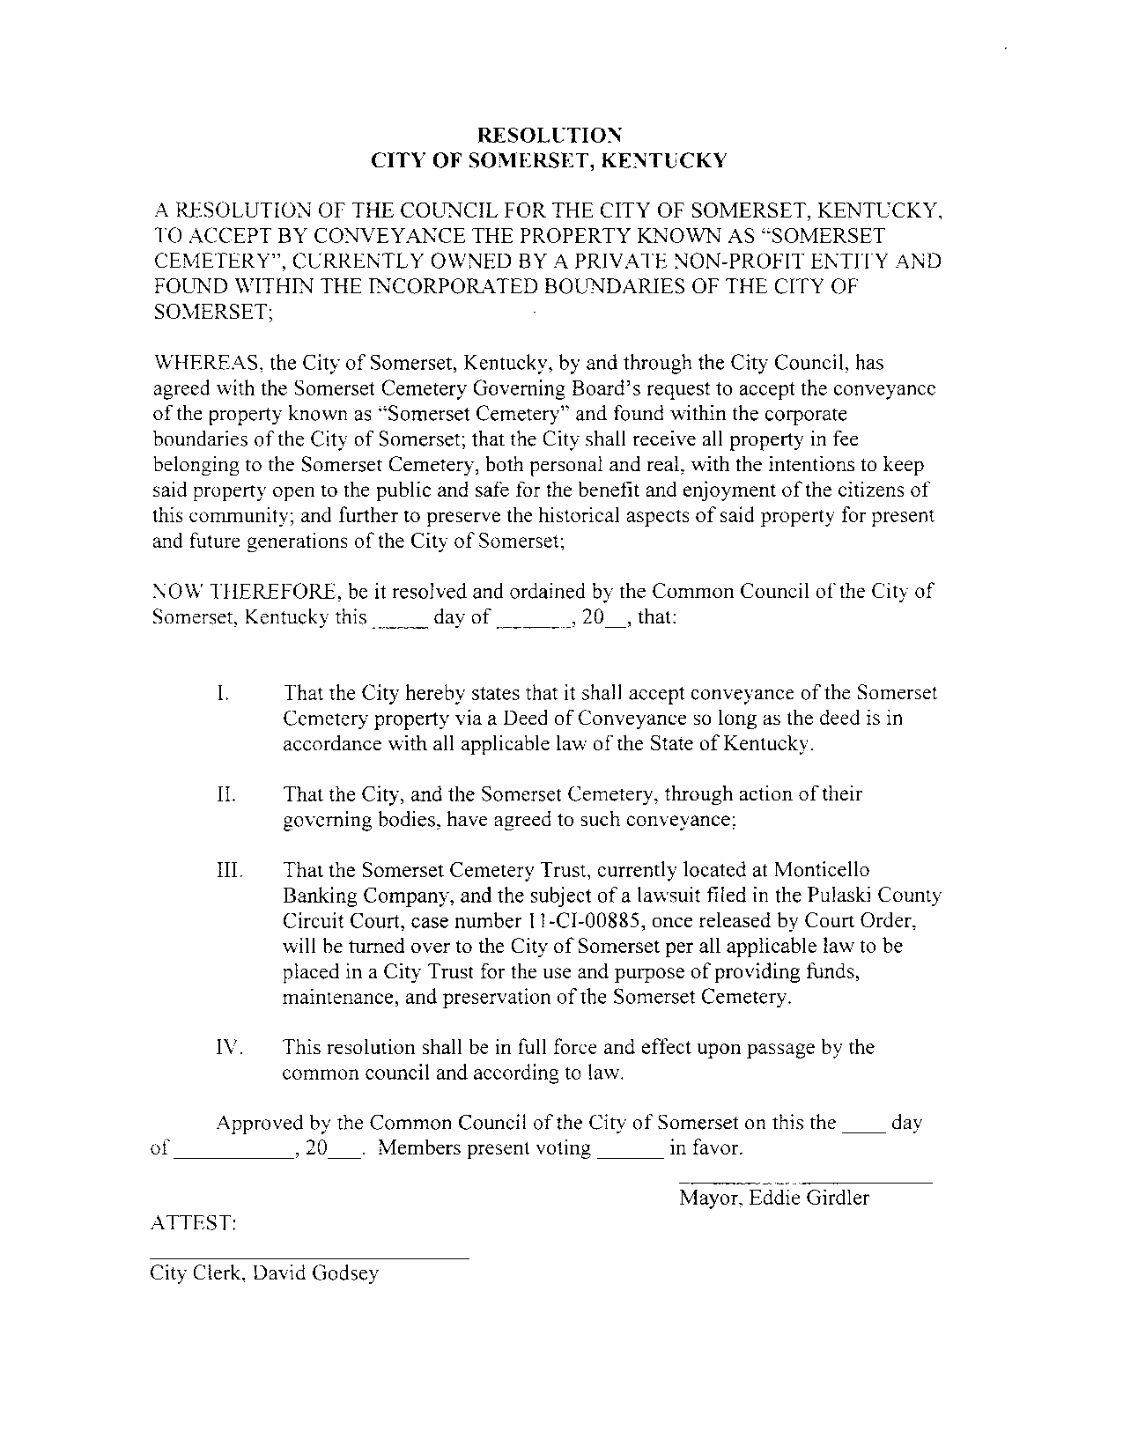

Mr. Burnett moved to approve the following Resolution requesting that committees be created for council to serve as members. Mr. Bourne seconded the motion. Upon roll call the following Council Members voted “Aye”: Mr. Burnett, Mr. Eastham, Mr. Rutherford, Mrs. Stringer, Mr. Wheeldon, Mr. Beasley, Mr. Girdler, Mr. New, Mrs. Hunley, Mr. Minton, Jim Mitchell, and Pat Bourne.

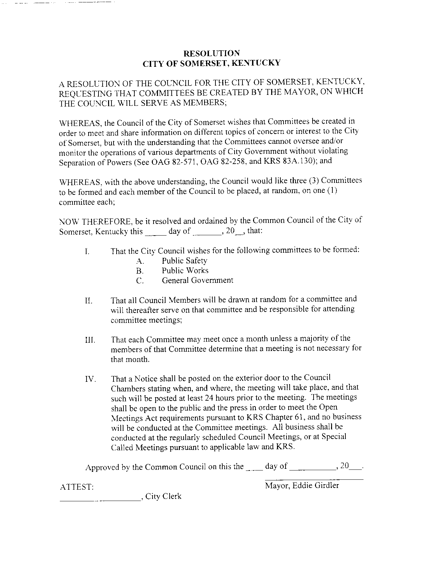

Page 2 of 3
Minutes of November 29, 2011
First reading was given the following Ordinance # 11-17:

First reading was given the following Ordinance # 11-18:

There being no further business the meeting adjourned.

APPROVED: MAYOR

ATTEST:
CITY CLERK

Page 3 of 3
Minutes of November 28, 2011

